**Preparation and Maintenance of ZOHO Books for Fresh Bites Catering**

Project Team members: LATHIKA.N, MAHALAKSHMI.B, MARIA STELLA MERY.A, MALINI.S

**1. INTRODUCTION**

**1.1 Overview:**

Fresh Bites Catering, a catering service, utilizes ZOHO Books to manage their sales, track inventory, and handle invoicing. They can generate professional invoices for clients and track expenses related to ingredients and supplies. ZOHO Books helps them maintain accurate financial records and streamline their catering operations.

**1.2 Purpose:**

By maintenance of accounts in ZOHO Books, We have created the Items, Vendors creating preparation of purchase order, purchase invoice, customer creation, preparation of sales order, Sales invoice, creation of bank account, creation of new accounts, recording journal entries, recording expenses, recording bank receipt and payments and viewing of financial reports like profit &loss account, Balance sheet, GST Reports, journal reports, Account receivable summary report, Account payable summary report, etc.,

**2. Problem Definition & Design Thinking**

2.1 Empathy Map

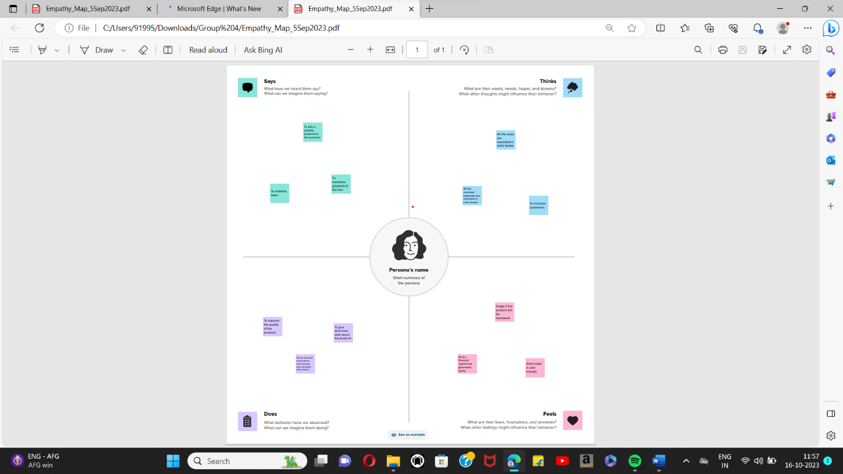

2.2 Ideation & Brainstorming Map

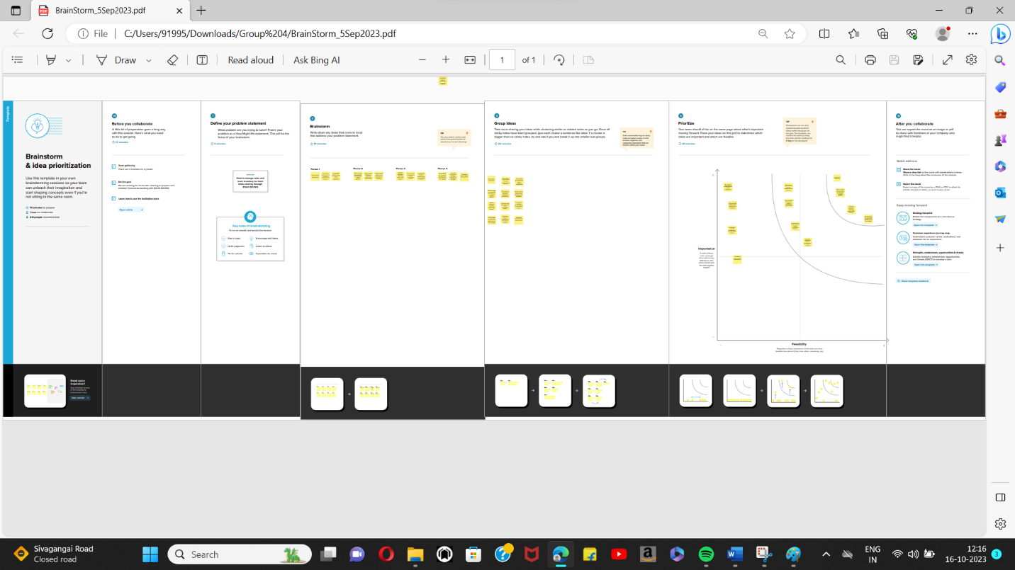

**3. RESULT:**

To Generate the Financial Reports:

1. Profit and Loss Account:

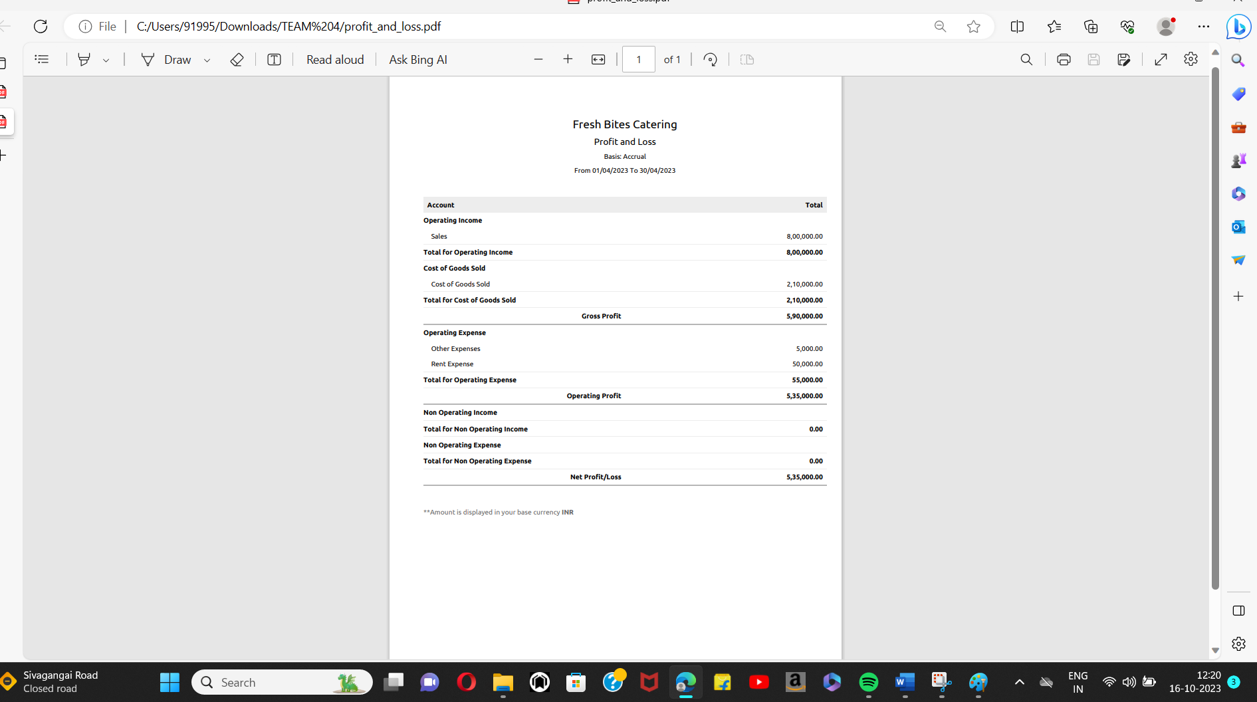

2. Balance Sheet

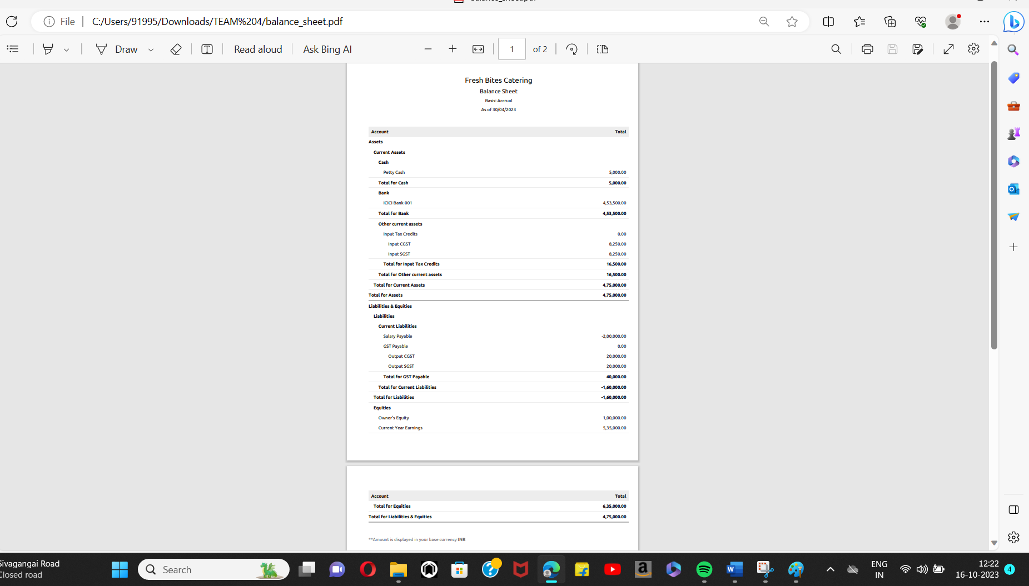

3. GST Reports

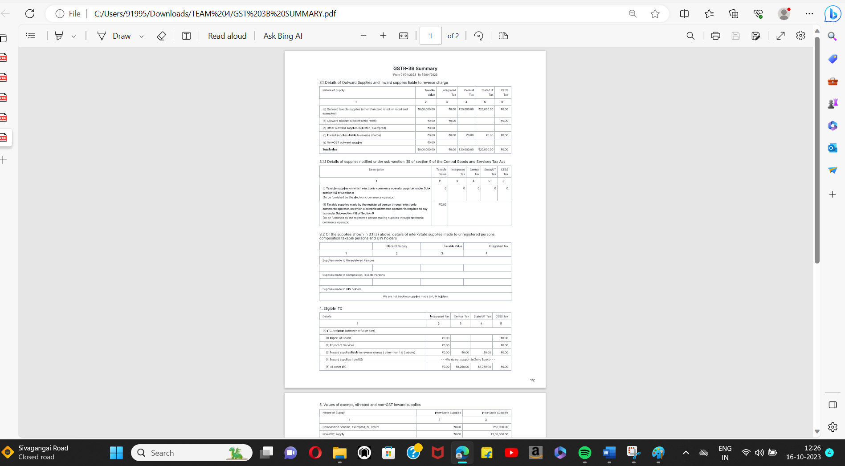

4. Journal Report

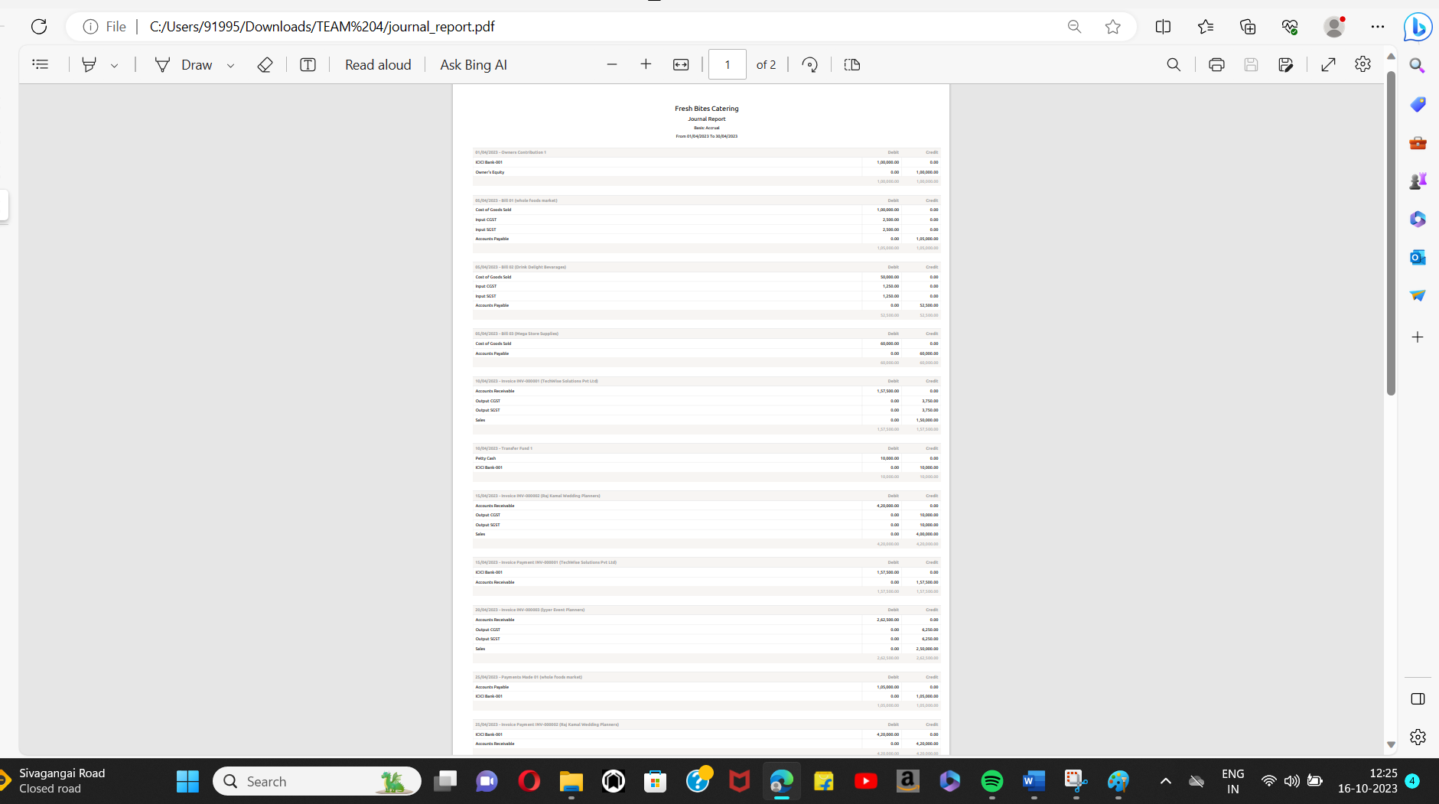

5. Accounts Receivable Summary

6. Accounts Payable Summary

**4. ADVANTAGES & DISADVANTAGES**

List of advantages:

* ZOHO books is cloud based software, so we access the software in any location.
* Creating of Organistion is very easy and user friendly.
* Appearance of software model is very easy to understanding.
* Creation of items, vendors, customers are user friendly while compare with software
* Preparation of purchase order and conversation to purchase Invoice made in a single step.
* Preparation of Sales order and conversation to Sale Invoice made in a single step.
* Default accounting step up is very useful and time saving.
* GST procedure is very easy to enter.
* Getting financial report and tax report in single step.

List of disadvantages:

* ZOHO books is cloud based software, which need internet and other technical facility.
* In absence of internet facility, the working in ZOHO books is very difficult.
* There is no secure in data of the organization.

**5. APPLICATIONS:**

The ZOHO Books is good software in all type of organization and we get better results instantly. We collect the following data and entered in ZOHO Books in various modules like item creation, Vendor creation, customer creation, preparation of Purchase order, Purchase Invoice, sales order, sale Invoice, Making payment to vendors and Expenses, Received amount from Customers.

**Item creation:**

Lets Assume Fresh Bites Catering is offering below services:

1. Corporate Catering Rs.300/- per plate

2. Wedding Catering Rs.400/- per plate

3. Buffet Catering Rs.500/- per Plate

Output GST @ 5% is applicable for the above services.

It requires below Purchase items for the supply of above services:

1. Food Ingredients ( Cost price is Rs.500/- per Kg)

2. Beverages (CP is Rs.100/- each)

3. Catering Supplies (CP is Rs.300/- each)

**Vendor creation:**

The following are the list of vendors form which various Products are purchased:

1. Whole Foods Market (GST registered)

2. Drink Delight Bevarages (GST registered)

3. Mega Store Supplies (Non GST)

**Customer creation:**

The below are the list of customers:

1. Tech Wise Solutions Pvt Ltd (GST Registered).

2. Raj Kamal Wedding Planners (GST Registered).

3. Iyyer Event Planners (Non GST)

**Preparation of Purchase order, Purchase Invoice:**

Next Fresh Bites Catering has raised below purchase orders from the vendors:

1. 05-04-2023 Whole Foods Market – Food Ingredients - Qty 200 - GST @ 5%

**Preparation of sales order, sale Invoice:**

Fresh Bites Catering received below Sales Order from the mentioned Customer:

1. 10/04/2023 Tech wise Solutions – Corporate Catering for 1000 plates - paid through bank on 15/04/2023

**Making payment to vendors and Expenses:**

Next Fresh Bites Catering purchased directly from the below Suppliers:

1. 05-04-2023 Drink Delight Bevarages – Beverages- Qty 500

2. 05-04-2023 Mega Store Supplies- Catering Supplies- Qty 200

**Received amount from Customers:**

1.15-04-2023 Amount received from TechWise Constructions 59,00,000

2. 20-04-2023 Amount received from Growmore Careers 11,80,000

**6. CONCLUSION:**

In maintain of Fresh Bites Catering in ZOHO Books is very smart in all the aspects of entries. The basic accounting concept is enough for the operating person(Accountant/Data entry operator). This software is applicable for all types of organization. The entry models of software are easily understood and interest to work. Whatever reports we need, it’s already default in the report models. Totally it’s a good and very useful to the entire entrepreneur with low cost for operating financial department.

**7. FUTURE SCOPE:**

The idea for the founders of ZOHO Books is amazing and very clever. This is a great milestone in the field of accounts maintenance. They offer various plane as per the requirement of the proprietors. It’s a good gift to all the entrepreneurs.